1. Risk Factors include:
2. obesity
3. high blood cholesterol
4. high blood pressure (hypertension)
5. smoking
6. 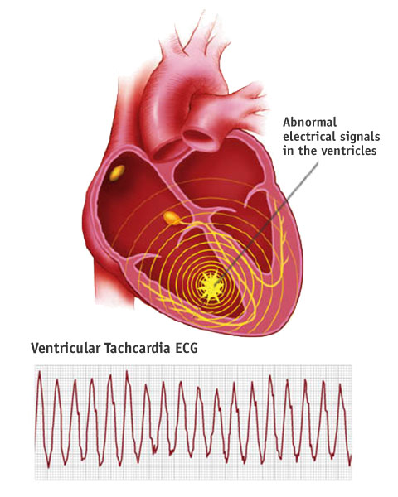lack of exercise (Remember your heart has MUSCLE tissue!)
7. diabetes
8. genetics
9. Tachycardia – a rapid heart beat

due to conduction system not

working properly

1. Atrial fibrillation – walls of atria quiver and

blood does NOT empty into the ventricles

(very serious!)

1. Ventricular fibrillation – walls of ventricles quiver and blood does NOT empty out of ventricles (fatal if not treated immediately!)

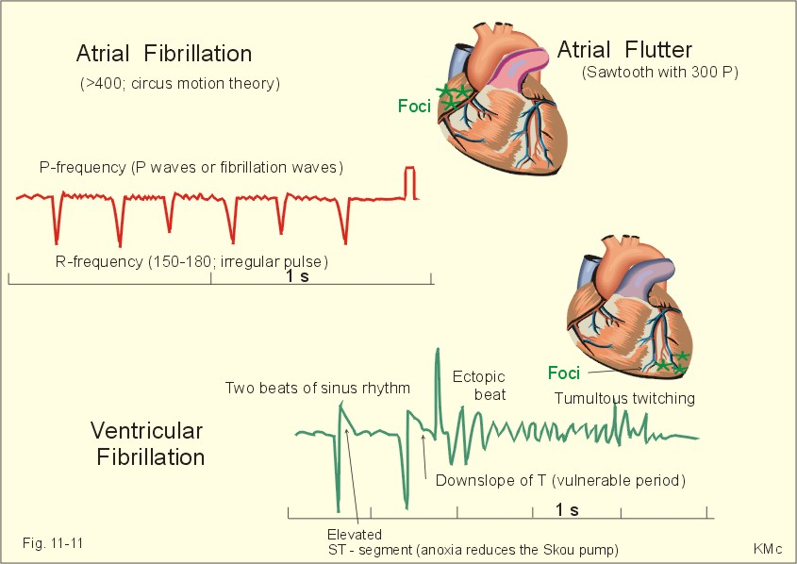

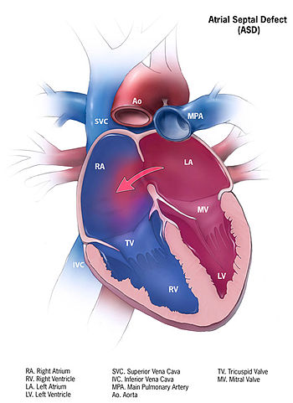

1. Atrial septal defect – a congenital heart defect,

foramen ovale in septum does not close up

after birth so oxygen-rich blood goes from left to

right atrium and mixes with deoxygenated blood,

can make you very tired

1. Ventricular septal defect – blood low in oxygen

in right ventricle goes to left ventricle, skin,

fingernails, and lips look blue

1. Heart murmurs – blood leaks through the heart in

the wrong direction if a valve does not close

properly, can be heard with a stethescope